Capstone Proposal: Cornursery
Introduction
It’s no revelation that modern technology is designed to bombard us with distractions. When a world of entertainment, social interaction, and other escapes from our work is literally at our fingertips, remaining focused on what needs to be done becomes a constant struggle. Research in learning disabilities and attention deficits has taken an interest in the rise of digital distractions, citing ease of access to technology as a primary distractor for students (Parsey & Schmitter-Edgecombe, 2013). In my own experience, the hardest part of the finals week grind is keeping myself at my computer and on task for an extended period. I always want to pace around, go for a walk, do anything but stay at my computer. And with how quick and easy it is to open a distraction, simply closing other windows and turning other devices off is not enough, when our phones spring to life in a few seconds and the entire internet is only a click away. The idea I had to address this issue is to create a controlled distraction: something that intentionally distracts the user, but to a degree where the distractions are infrequent and brief, but frequent enough to keep a person engaged. Rather than push straight back against our urge to engage with distractions, my approach is to scratch that itch, but to do so efficiently.
My target for this project is my fellow students with neurodivergences or learning disabilities, as they are especially prone to distraction. I plan to do this by creating a controlled distraction game, one that sits on top of other windows and encourages regular engagement every few minutes, keeping a person at their computer and engaged without demanding so much attention that the users are completely disengaged from their task. I’ll be using the Unity 2D Engine to develop the game. Similar ideas have been attempted before, as I will go over shortly, but I think they don’t hit the sweet spot of being engaging without being too distracting.
Success will be difficult to measure as there are two objectives: make a complete game, and have it produce the desired responses from testers. The first is largely a personal goal; whether I’m satisfied with the game I produce. Whether it plays, looks, and sounds how I hope it will sound is likely to change as I develop the game, and is more of a secondary objective. Making the game too polished could make it more distracting, so it is a careful balance. The second goal is mostly going to be informed by anecdotes from testers. Whether the game is too distracting, or not engaging enough, or hits that sweet spot I want to hit will mostly be informed by my testers, making constructing a working demo a high priority so their thoughts can influence my final version.
Games take a long time to develop, but this is a relatively simple one that has many “stop” points where the game is functional, even if it is not as polished as it could be. This means that the space to develop is more than sufficient for a capstone project, while at the same time, the minimum scope for success should be well within the means of what can be accomplished within the limited time frame. My hope is to not stop at the bare minimum, but rather to see how far I can stretch this project. I already have access to an engine and a pixel art editor, so I have the resources I need to produce this game. While I have worked in Unity before, I haven’t made a 2D game yet, so this project will be a strong mix of applying my skills and learning new ones.
Background
A similar idea for this game concept has been attempted by other developers before, and I highlighted 3 that I have used: foolsroom’s Cornerpond, Conradical Games’s Desktop Defender, and Marcel Zurawka and Julius Kr$\ddot{u}$ger’s Bongo Cat. All 3 of these games do what I described as the primary function of Cornursery. They all sit in the corner of your screen by default, always overlayed over other windows even when out of focus. Some of them, particularly Cornerpond, even advertise on the same idea of being a background game of sorts. However, I think all 3 of them miss that sweet spot I talked about. In Cornerpond and Bongo Cat, it is very easy to make progress while away from the computer for extended periods once you have played them enough. And while the same is somewhat true of Desktop Defender, it is also notably more colorful, active, and demanding of user engagement for optimal play. This means the game ends up taking up more focus than one might want. Ideally, we want to find an in between: a game that is engaging enough to keep a user at their computer, but “muted” enough to not be your primary focus while it is running.
That said, this project is undoubtedly closely inspired by Cornerpond. I think the game’s visual style, concept, and general tone is strong and fits what I am going for. However, I think there is room to improve upon that foundation, especially regarding keeping users at their computers and disincentivizing idle play.
Before committing to this project, I wanted to do some more research on controlled distractions and whether they’re considered effective. Doing some research on learning disabilities and attention deficits, I found some research about using music as a controlled distraction for students with learning struggles. One piece of note I found was that supposedly giving students a choice on their controlled distraction improved its effectiveness, so adding alternative distractions to the existing pool is useful (Homann, Drody, & Smilek, 2023). Some pointed out that music with lyrics would often demand too much attention for some students, an experience I’ve had myself (Velasco & Moreno, 2025). That’s a strong example of finding a sweet spot for the controlled distraction we are developing.
There’s notably not a lot of work on using games as a controlled distraction, though there is research on game-ified learning and VR learning environments (Kurt & Tomul, 2026). I hope to use this music research as a proxy to inform my approach. I also think I can learn from their testing strategies to inform my own testing and demos as well.
Methodology
I plan to make a video game in Unity that will serve as a controlled distraction by allowing users to overlay it over other windows and only demand interaction every couple minutes. This will be done with a milestone-focused approach that uses the major dates in the class as progress markers. I have a series of hard deadlines that I will go over in the timeline section to ensure I am on track to have a finished version of the game ready by the end of the semester.
Most notably, I want to have the window ready within the next week so I can ensure my development environment is ready. If I can have a working user interface by then, that would be perfect, but it isn’t required. I want to keep goals for each section reachable, while having stretch goals to encourage me to push further.
Speaking of encouragement, a non-functional but important feature is a progression system. The controlled distraction won’t be effective if I can’t motivate users to want to have it running while they work. As such, having a money system for selling finished plants, new plants, upgrades to improve plant value and growth rate, and so on can help motivate users to keep playing. Giving players options to progress will encourage them to use the program, and since the game on its own should be pretty boring, it will encourage them to have something to work on if they want to make progress as well. Lastly, having a logbook to encourage users to seek out and catalog new plants can further encourage them. Shown below is an early diagram of the system architecture, and this non-functional requirement concerns the Plant Collection, Inventory, and Store sections.
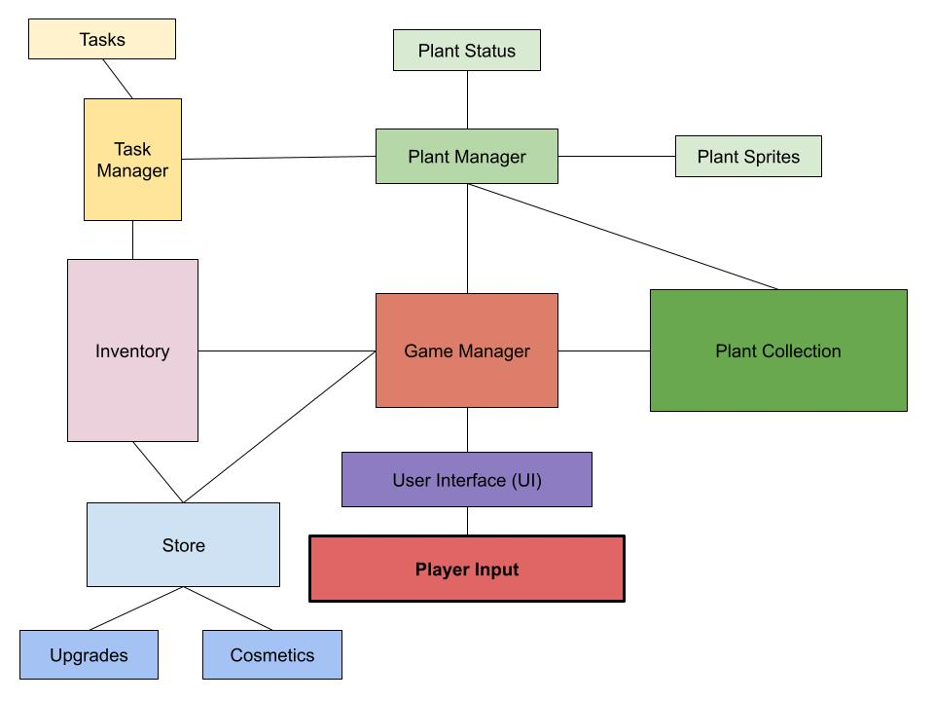
Stepping back a bit, the user requirements would be the plant growing system and the window functioning as intended, so that is my priority. These will also be the requirements for the first demo. All this means is the window works as intended, and the game has its fundamental plant growing system. This means the game would work as intended, there just may not be a “purpose” beyond being a controlled distraction. It wouldn’t necessarily hook a user and encourage them to use it, but it would be functional by this point. At this point the UI, Game Manager, Plant Manager, and Task Manager systems, as well as their smaller components, should be working.
The last non-functional requirement I’ll speak on is more general: the game should be fun. If it’s not fun, it won’t motivate people to use it. If I want to reach users who struggle with short attention spans and learning disabilities, making the game as lucrative as possible would help, and it would validate making a game over some kind of educational tool. It’s not a requirement per se, but it would help extensively with the purpose.
Testing
My main method of testing will be after the partial demo is complete. Outside of developer-end bug testing and unit testing, which would involve running the game and seeing if anecdotally the game is progressing at the rate I’d hope for, I need the demo to be done. From there, I’ll give the demo to other students and ask them to run it in the background while they work on other things. Then I’ll take feedback through an online form, asking for specific input and asking a few yes/no questions, like whether they felt it was too distracting, and whether it encouraged them to stay at their computer. I’ll also have free response questions for any assorted feedback they have, in case anyone has specific remarks. I should ideally have at least 15-20 subjects.
I’ll create a faster developer build of my game to test features faster, ideally drastically cutting down on how long it would take to test progression and playtime statistics. Since the game is designed to progress slowly, an easily adjustable developer build for testing can ensure that I won’t have to run the game for several days to run a single test for a later feature. Test cases will be difficult to develop for a game, beyond some basic feature tests. Playtesting is the primary method of testing games, which means actively engaging with my own game a lot. Once I have a good working build, I can test it in its normal build state myself on top of users, but I think user input from many people would be ideal.
Organization & Timeline
I don’t have any other members in my group so I don’t need to organize beyond my timeline and plan as I’ve outlined in this proposal.
- February 19: Working game window
  - Stretch goal: Working UI
- April 1: Soft deadline for partial demo. All major bugs must be fixed by the 9th.
- April 9: Partial demo, plant growing features working (maybe finish this early to get started on playtesting ASAP?)
  - Stretch goal: Shop and cosmetic upgrades
- April 30: Full polished version of the game. Doesn’t need anything specific but would ideally have upgrades, more cosmetics, more plants, and enhanced visuals.
References
Conradical Games. (2025). Desktop Defender [Steam].
Foolsroom. (2025). Cornerpond [Steam].
Homann, L.A., Drody, A.C. & Smilek, D. (2023). The effects of self-selected background music
and task difficulty on task engagement and performance in a visual vigilance task. Psychological Research 87, 2460–2476. https://doi.org/10.1007/s00426-023-01836-6.
Kurt, A. D., & Tomul, E. (2026). The Role of Virtual Reality in Teaching Fractions in
Mathematics for Students with Learning Disabilities: The Role of Virtual Reality in Teaching Fractions in Mathematics for Students with Learning Disabilities. International Journal of Science and Mathematics Education, 24(2), Article 5. https://doi.org/10.1007/s10763-025-10636-w.
Parsey, C. M., & Schmitter-Edgecombe, M. (2013). Applications of Technology in
Neuropsychological Assessment. Clinical Neuropsychologist, 27(8), 1328–1361. https://doi.org/10.1080/13854046.2013.834971.
Velasco, E., & Moreno, M. (2025). Music and online learning: new perspectives and directions.
Educational Technology Research and Development, 73(4), 2567–2587. https://doi.org/10.1007/s11423-025-10491-0.
Zurawka, M. & Kr$\ddot{u}$ger, K. (2025). Bongo Cat [Steam].

